**Date:** 16/03/2021

**Roll No. :** 20BCE503

**Name:** Jaimik Chauhan

**Course Code and Name:** 2CS405 (Web Technologies)

**Practical No.:** 1

**AIM:**

a. Design an HTML page using text level tags and block level tags.

b. Design an HTML page using different types of lists to demonstrate

nesting of the lists.

**Code :**

1. <html>
3. <head>
4. <title>First Practicle </title>
5. <style>
6. body {
7. width: auto;
8. height: 100%;
9. background-color: antiquewhite;
10. color: black;
11. }
13. .headings {
14. width: auto;
15. height: fit-content;
16. text-align: right;
17. margin-bottom: 5%;
18. border: 2px solid black;
19. }
21. .headings p {
22. text-align: center;
23. margin: 2%;
24. font-size: larger;
25. }
27. .p-tag {
28. width: auto;
29. height: fit-content;
30. padding: 2%;
31. background-color: rgb(247, 225, 225);
32. color: black;
33. text-align: center;
34. font-size: 24px;
35. }
37. .p-tag b {
38. font-size: 32px;
39. font-weight: bold;
40. }
42. footer {
44. text-align: center;
45. width: auto;
46. height: fit-content;
47. background-color: black;
48. color: white;
49. margin-top: 10%;
50. padding: 5px 5px;
51. }
53. a:hover {
54. color: red;
55. text-decoration: overline;
56. }
58. a:active {
59. color: gray;
60. }
62. a:visited {
63. color: rgba(67, 78, 126, 0.534);
64. }
66. a:link {
67. color: blue;
68. background-repeat: red;
69. border: 2px solid blanchedalmond;
70. text-decoration: none;
71. }
73. h2#t1 {
74. border: 2px solid black;
75. height: fit-content;
76. width: fit-content;
77. padding: 1%;
78. }
80. .vertical {
81. height: fit-content;
82. width: fit-content;
83. }
85. header {
86. text-align: center;
87. font-size: larger;
88. }
89. </style>
90. </head>
92. <body>
93. <header>
94. <h2>Practical-1</h2>
95. </header>
96. <div **title**="Headings" **class**="headings">
97. <p> Heading Tags</p>
98. <hr />
99. <h1 **style**="vertical-align: baseline;">Heading 1</h1>
100. <h2 **style**="vertical-align: text-top;">Heading 2</h2>
101. <h3 **style**="vertical-align: text-bottom;">Heading 3</h3>
102. <h4 **style**="vertical-align: sub;">Heading 4</h4>
103. <h5 **style**="vertical-align: super;">Heading 5</h5>
104. <h6>Heading 6</h6>
106. </div>
107. <div **class**="p-tag">
109. <mark><b>Note </b></mark>
110. <p> <small>This</small> <del>Is</del> <ins>Written</ins> inside paragraph tag. <strong>Hey, good
111. afternoon.</strong> Hello
112. there!!!
113. </p>
114. <p>This also witten in another <em>tag.</em> </p>
115. <i>this is br tag</i> <br /> <u>hello.</u>
116. <br>
117. <a **href**="i1.html">Next Page</a>
118. </div>
119. <div **class**="vertical">
120. <h2 **id**="t1"><img **src**="ne.png" **style**="vertical-align: baseline;" **height**="15px" **width**="15px" /> Hello World
121. (baseline)</h2>
122. <h2 **id**="t1"><img **src**="ne.png" **style**="vertical-align: bottom;" **height**="15px" **width**="15px" /> Hello World (bottom)
123. </h2>
124. <h2 **id**="t1"><img **src**="ne.png" **style**="vertical-align: top;" **height**="15px" **width**="15px" /> Hello World (top) </h2>
125. <h2 **id**="t1"><img **src**="ne.png" **style**="vertical-align: text-bottom;" **height**="15px" **width**="15px" /> Hello
126. World(text-bottom)
127. </h2>
128. <h2 **id**="t1"><img **src**="ne.png" **style**="vertical-align: middle;" **height**="15px" **width**="15px" /> Hello World
129. (middle)</h2>
131. <h2 **id**="t1"><img **src**="ne.png" **style**="vertical-align: super;" **height**="15px" **width**="15px" /> Hello World
132. (super)</h2>
134. <h2 **id**="t1"><img **src**="ne.png" **style**="vertical-align: sub;" **height**="15px" **width**="15px" /> Hello World
135. (sub)</h2>
136. </div>
137. <div>
138. <h3>Sem-3 Subjects : </h3>
139. <ul>
140. <li>OOP</li>
141. <li>DSA</li>
142. <li>DE</li>
143. <li>DC</li>
144. <li>DM</li>
145. <li>POE</li>
146. </ul>
147. <h3>Sem-4 Subjects</h3>
148. <ol>
149. <li>DBMS</li>
150. <li>OS</li>
151. <li>PSC</li>
152. <li>PS</li>
153. <li>WT</li>
154. <li>CA</li>
155. </ol>
156. </div>
157. <footer>
158. Jaimik Chauhan©
159. <br>4<sup>th</sup> Sem Student
160. </footer>
161. <script>
162. function previous() {
163. window.history.back();
164. }
165. </script>
166. </body>
168. </html>

**Output :** 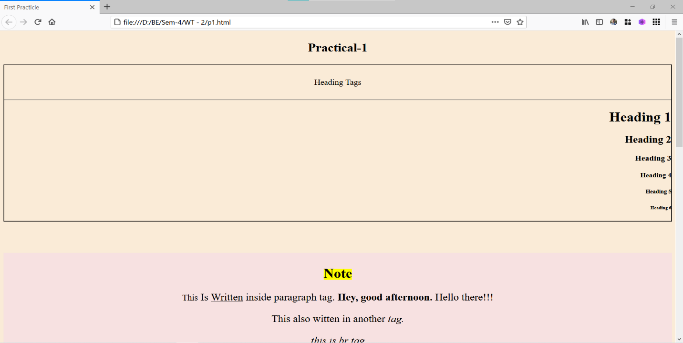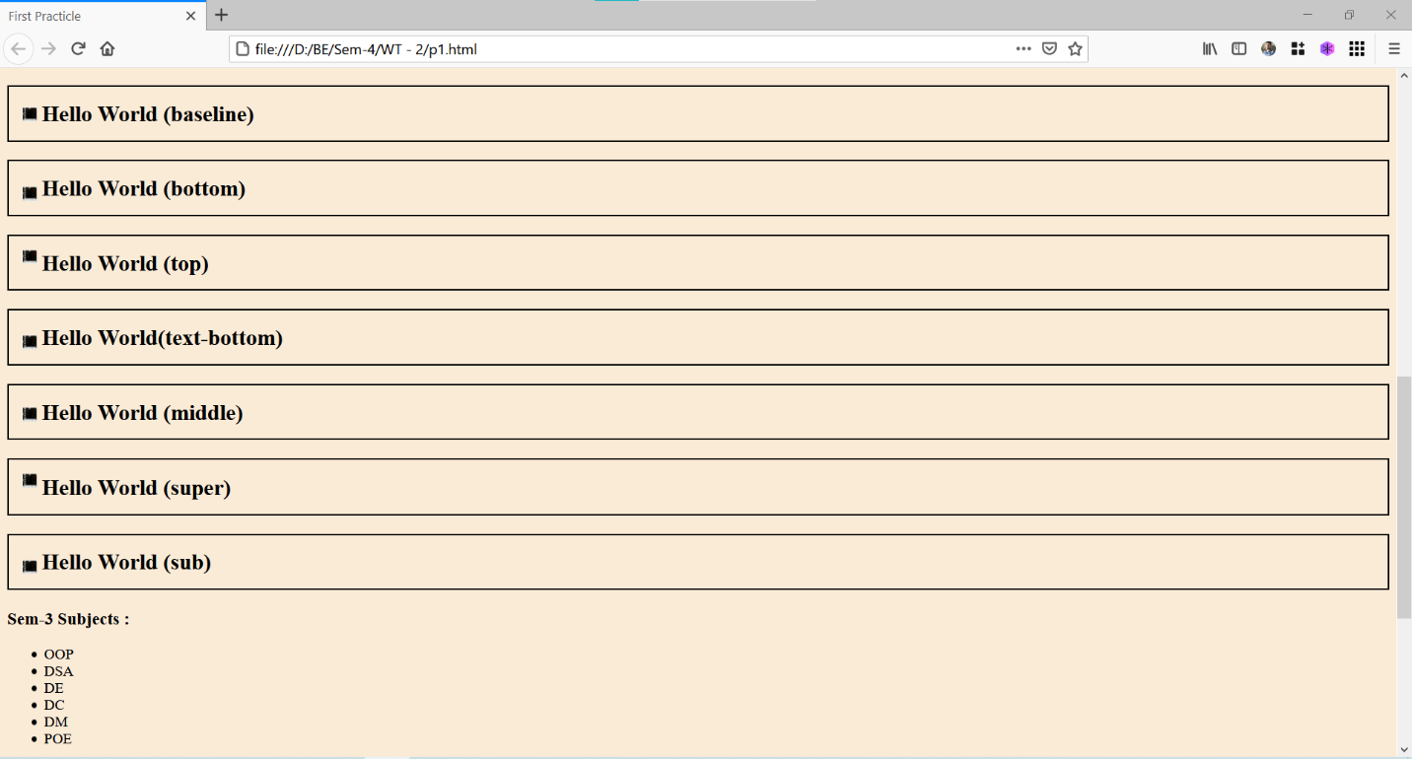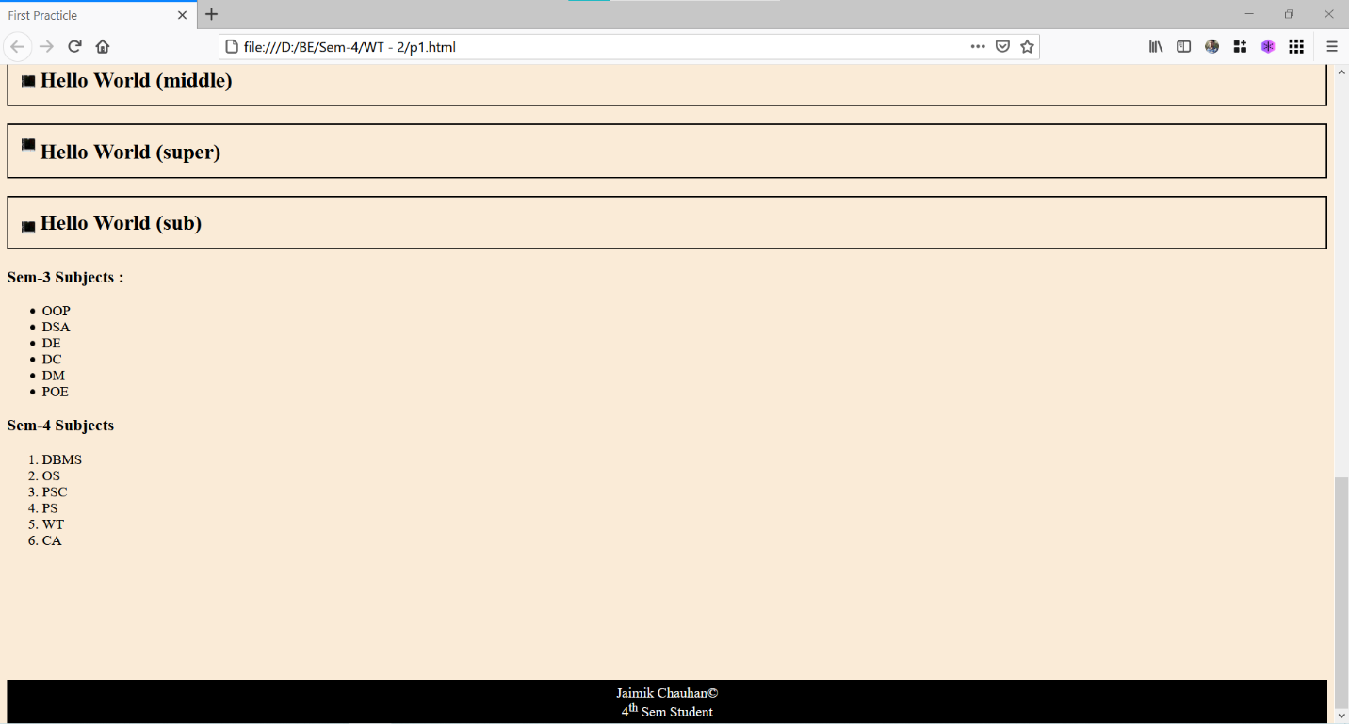

**Conclusions :** Performing This Practical, I Learnt Some New Tags Such as <strong>, <em> etc. Also Learn How To Make HTML Page Respnosive.